1. Write an HTML program to display the following using inline, embedded and external stylesheets:

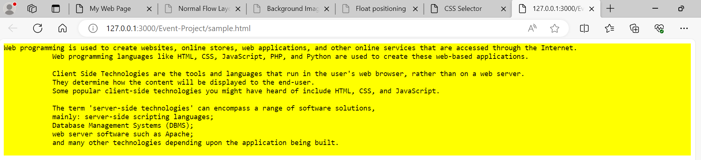

2. Given the following style file and the output snapshot, write HTML code recreate the output. Write down the types of selectors inheritance used in the code.

p

{

    font-size:x-large;

    background-color: lime;

}

\*{

   font-family: monospace;

}

a:link{color:black;}

a:visited{color:yellow;}

a:hover{color:blue;}

a:active{color:red;}

#p2

{

  color:yellow

}

#box

{

  background-color: white;

  border: 10px dotted blue;

  width:50%;

  padding: 20px;

  margin:30px 20px;

}

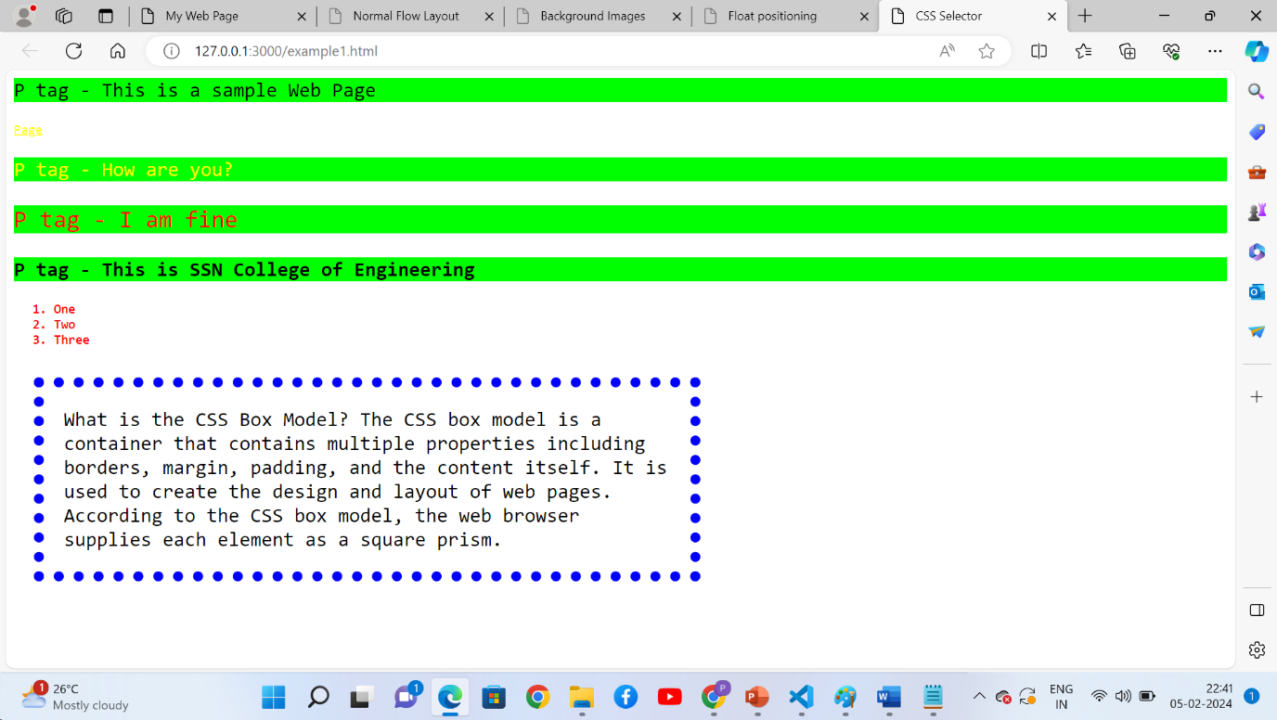

3. Place html, body, div, span elements and highlight the boxes of these elements using different styles using border, margin, and padding properties of CSS box.

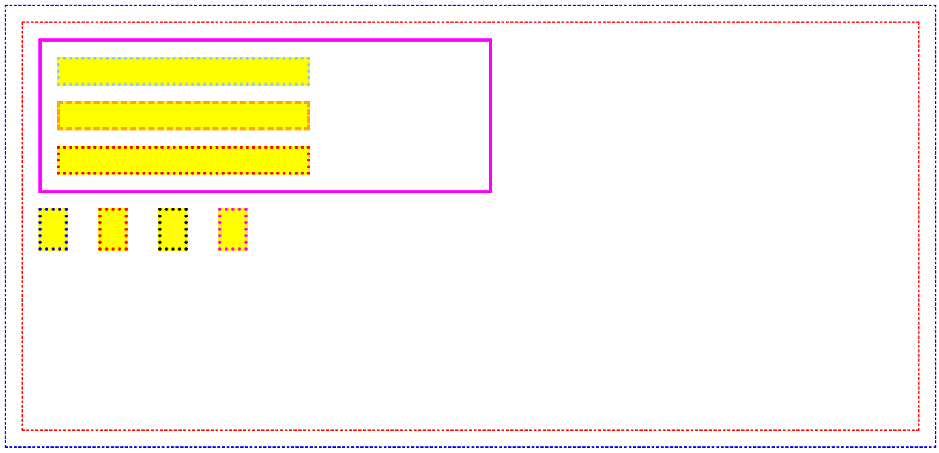

4. Place the background image and highlight the word *tree* using span element with the given style

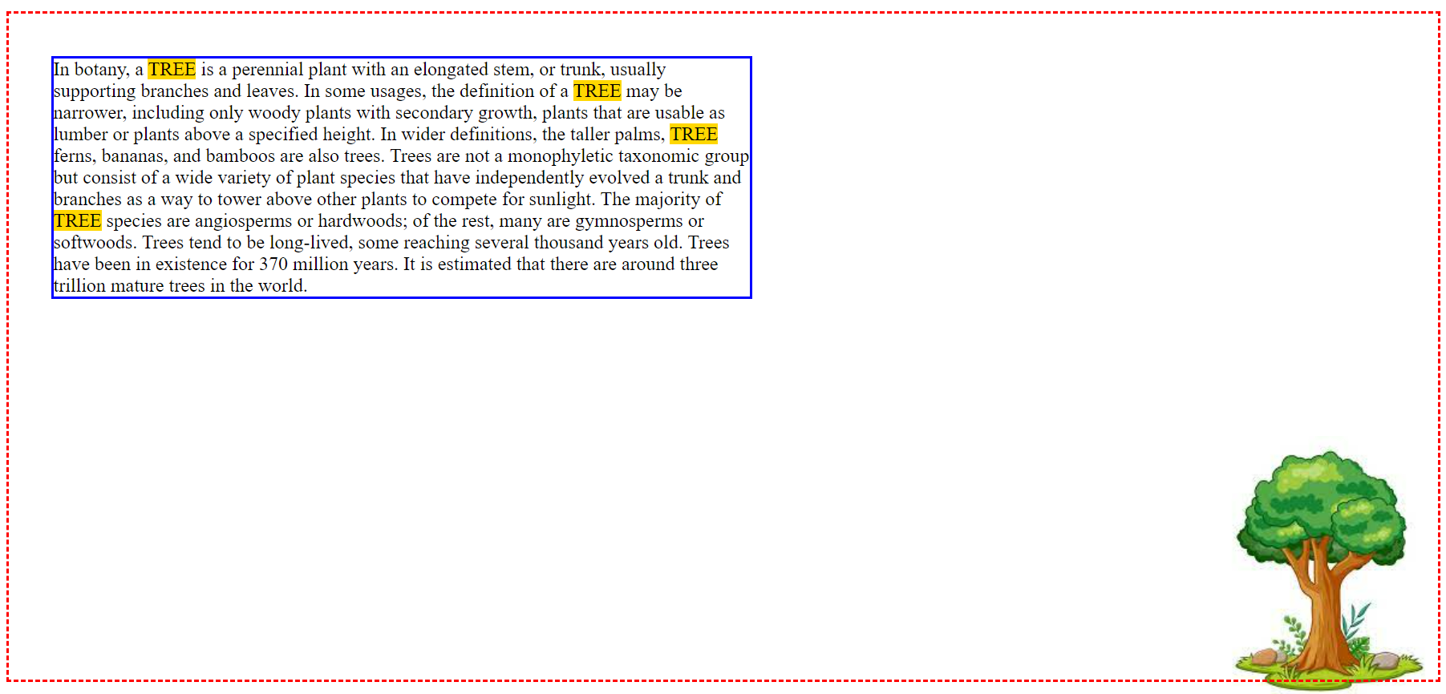

5. Create the definition of fruits using background image and float the word *fruit* using the following style.

